SIMATS ENGINEERING

Concept Mapping – CO1-AT2

Course Name:
COMPUTER NETWORKS (CSA-0707)

Presented By:

Name: M. Vaishnav
Register No: 192524251

Date:
21-07-2026

(Q.1.) Missing Layers in OSI Model

(Concept Map)

Application
↓
Presentation
↓
Session
↓
Transport
↓
Network
↓
Data Link
↓
Physical

Missing Layers

1. Session Layer

2. Data Link Layer

Explanation:

Session Layer

• Establishes communication sessions between devices.

• Maintains synchronization during data exchange.

• Controls dialog between sender and receiver.

• Responsible for session setup, management, and termination.

Data Link Layer

• Provides node-to-node delivery.

• Performs framing of data.

• Detects transmission errors using CRC.

• Uses MAC addresses for local communication.

How They Ensure Reliable Communication

• Session layer maintains continuous communication and recovers interrupted sessions.

• Data Link layer detects transmission errors and ensures correct frame delivery.

• Together with Transport and Network layers, they improve reliability and efficiency.

Conclusion

The complete OSI model consists of seven layers. The Session and Data Link layers play a vital role in maintaining communication and ensuring accurate data transfer, making network communication reliable.

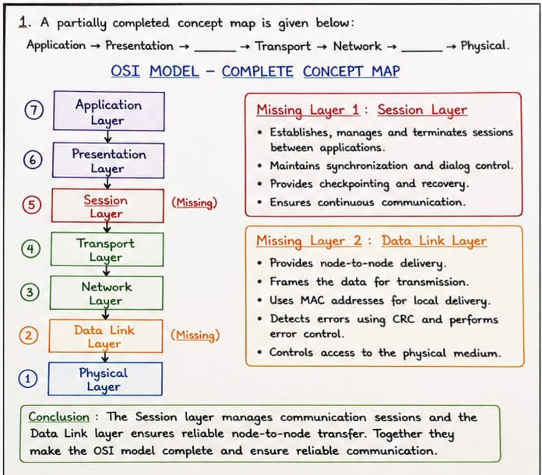
(Q.2.) Concept Map Linking Data Units with OSI Layers

(Concept Map)

Application / Presentation / Session
↓
Data
↓
Transport Layer
↓
Segment
↓
Network Layer
↓
Packet
↓
Data Link Layer
↓
Frame
↓
Physical Layer
↓
Bits
Relationship Between Layers and Data Units

OSI Layer Data Unit
Application Data
Presentation Data
Session Data
Transport Segment
Network Packet
Data Link Frame
Physical Bits

Transformation
Process:

1. Data → Segment

Transport layer divides data into segments.
Adds port numbers and sequence numbers.

2. Segment →Packet

Network layer adds IP addresses.
Creates packets for routing.

3. Packet → Frame

Data Link layer adds MAC addresses.
Creates frames for local delivery.

4. Frame → Bits

Physical layer converts frames into electrical, optical, or radio signals.

Importance of Transformation

• Enables data to travel through different network layers.

• Supports routing and addressing.

• Provides error detection.

• Ensures efficient and reliable communication.

Conclusion
Data undergoes encapsulation from Data → Segment → Packet → Frame → Bits. Each transformation adds layer-specific information necessary for successful transmission across networks.
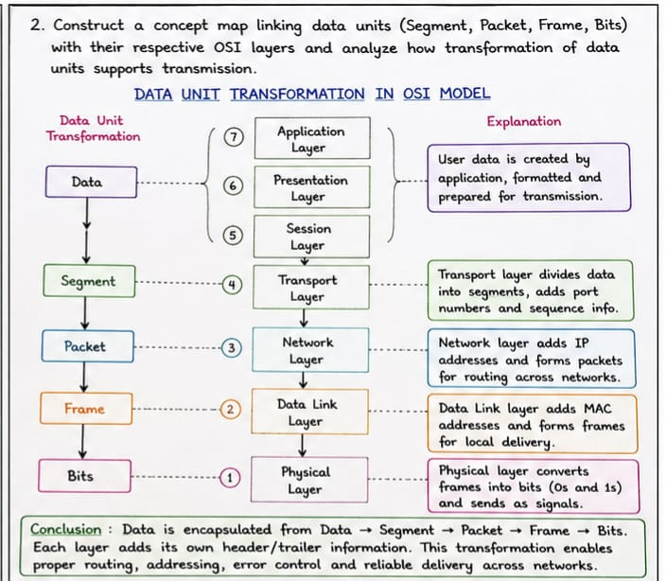
(Q.3.)Network Layer and Data Link Layer

(Concept Map)

Network Layer
↓
IP Address
↓
Global Delivery
↓
Destination Network
─────────────────────────
Data Link Layer
↓
MAC Address
↓
Local Delivery
↓
Destination Device

Explanation

Network Layer → IP Address → Global Delivery

Network layer uses logical addressing (IP Address).

• Determines the destination network.

• Routers use IP addresses to forward packets.

• Enables communication across different networks worldwide.

Example: A packet travels from Chennai to New York using IP addresses.

Data Link Layer → MAC Address → Local Delivery

• Data Link layer uses physical addressing (MAC Address).

• Delivers frames within the local network.

• Switches use MAC addresses for communication.

Example: A frame moves from a laptop to a Wi-Fi router within the same LAN.

How They Work Together

Application Data
↓
Transport
↓
Network (IP Addressing)
↓
Data Link (MAC Addressing)
↓
Physical Transmission

1. Network layer identifies the destination network using IP addresses.

2. Data Link layer identifies the destination device using MAC addresses.

3. Routers handle global delivery.

4. Switches handle local delivery.

Importance for Complete Data Delivery

• IP addresses provide end-to-end communication across networks.

• MAC addresses provide device-to-device communication within a network.

• Together they ensure successful delivery from source device to destination device.

Conclusion
The Network layer ensures global delivery through IP addressing, while the Data Link layer ensures local delivery through MAC addressing. Their combined operation guarantees complete and reliable data transmission across interconnected networks.

